|  |  |
| --- | --- |
| **Name:-** Aryan Dilipbhai Langhanoja | **Roll Number:-** 92200133030 |
| **Subject Name and Code:-** Foundation Skills in Sensor Interfacing (01CT1103) | **Date of Experiment:- 11-11-2022** |

|  |
| --- |
| Task:- |

Interface push button with Arduino Uno and control the LED.

|  |  |
| --- | --- |
| Components:- |  |

* Push-Button
* LED
* Arduino Uno R3
* Jumper Wires
* Bread Board
* Laptop Or PC
* Resistance

|  |  |
| --- | --- |
| About the Project: |  |

* In this project, we are going to interface Push-Button. And we control LED with Push-Button. There are two ways to do this task, First

|  |  |
| --- | --- |
| Schematic: |  |

* This Project we can do in 2 way, First way is Step Down resistance, in that we connect resistance with pin 2 and other with anode of LED and cathode of LED will be connected with ground. After that we will connect one leg of push button with pin 7 and other leg will be connected with 5V and one leg is connected in ground with resistance for reference which called step-down resistance.
* Other way is Step Down resistance, in that we connect resistance with pin 2 and other with anode of LED and cathode of LED will be connected with ground. After that we will connect one leg of push button with pin 7 and other leg will be connected with ground and one leg is connected in 5V with resistance for reference which called step-up resistance.

|  |
| --- |
| Output: (your circuit implementation and its working photo) |

1. 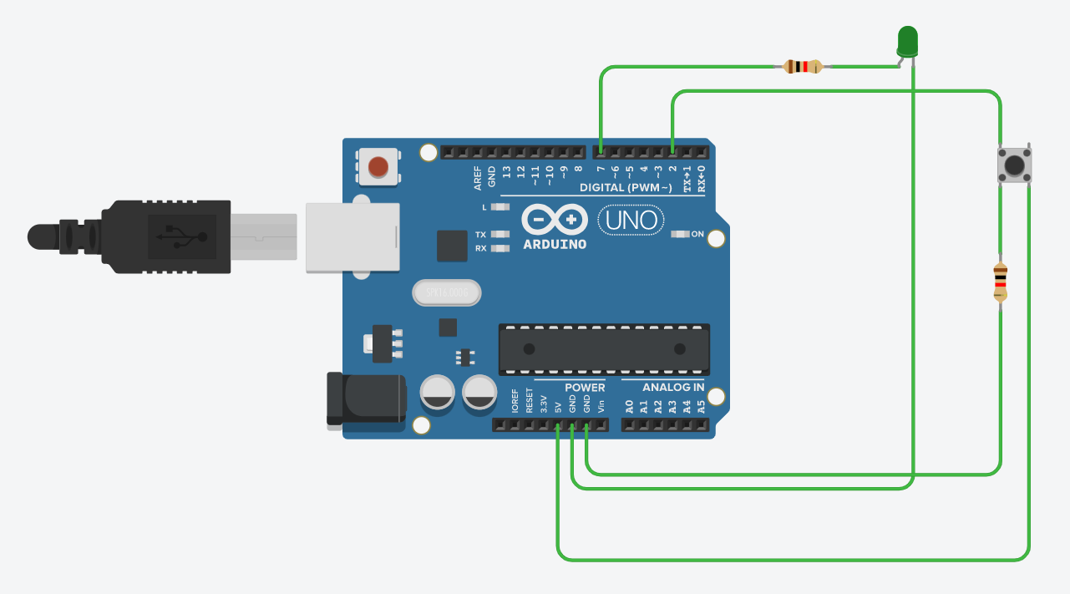**With Step-Down Resistance**

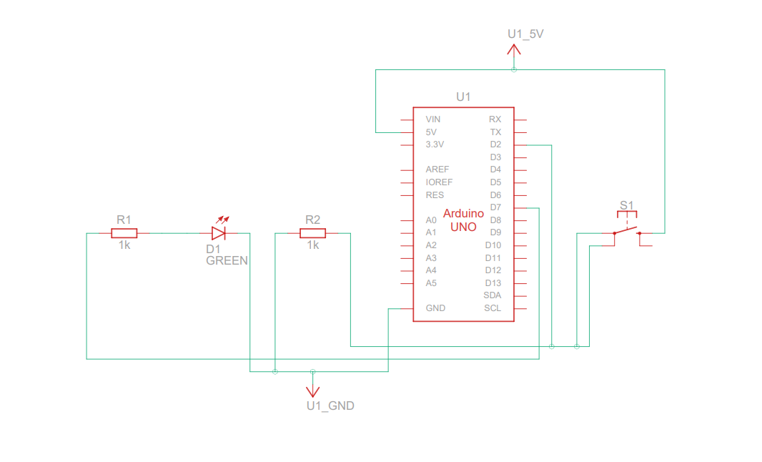

1. **With Step-Up Resistance**

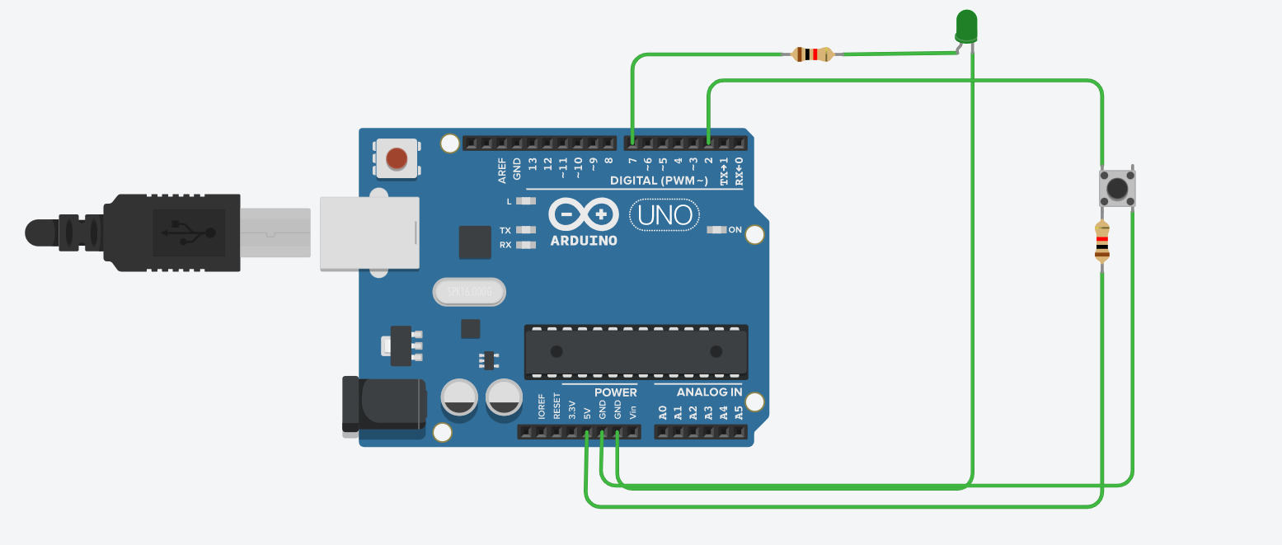

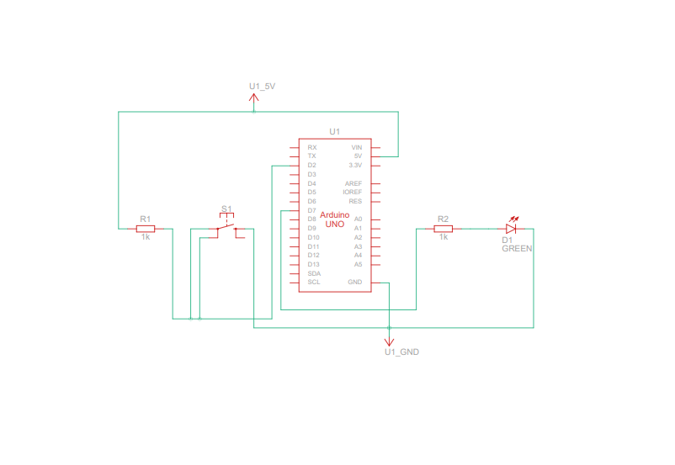

|  |  |
| --- | --- |
| Code: |  |

1. 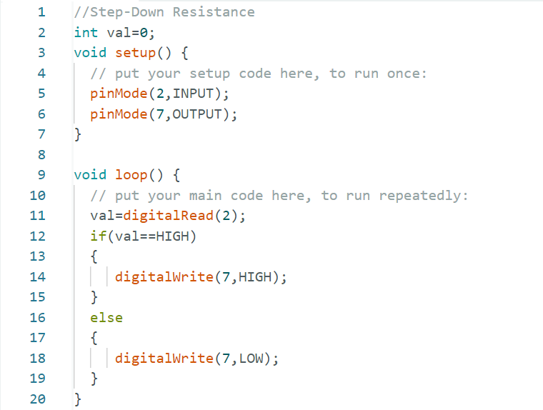**Step-Down Resistance**
2. 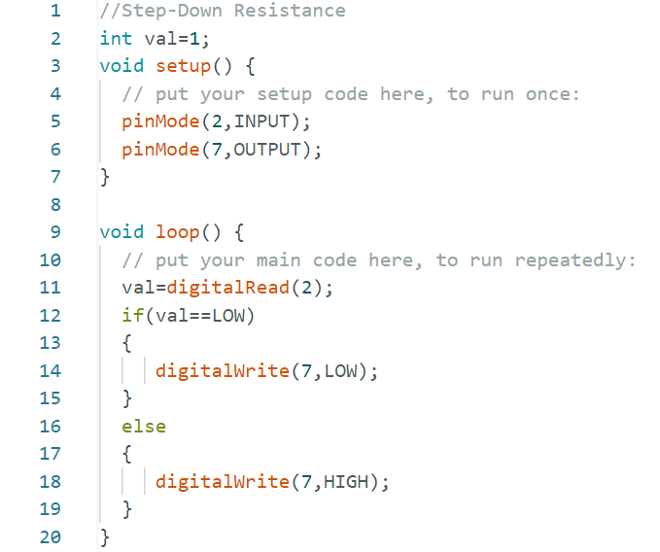**Step-Up**

**Resistance**

|  |  |
| --- | --- |
| Application:- |  |

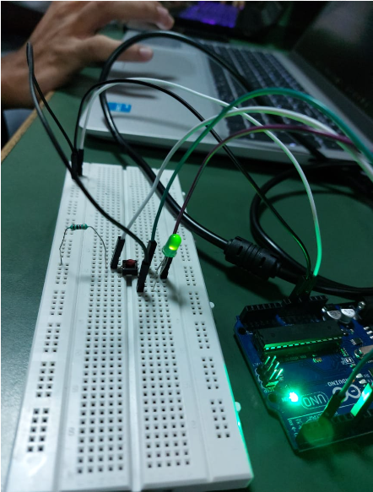

|  |  |
| --- | --- |
| Conclusion: |  |

* In this Task, We come to know about push button , Step-Up Resistance and Step-Down Resistance.